**MS101 | Makerspace Lab**

**________________________________________________________________**

Final Project Report

**________________________________________________________________**

Team Name: **P7 T7**

Team Members:

1. 22B1237 (Koushik Reddy)

Contribution – Procurement of some items

1. 22B1238 (Saumya Dharmesh Shah)

Contribution – Modelling and Fabrication of Chassis, Brainstorming, Assembly of Mechanical parts, Electrical connections and coding, debugging

1. 22B1239 (Vanka Mahithanvitha)

Contribution – Model Assembly, Brainstorming, Video Editing

1. 22B1240 (Rushil Malode)

Contribution – CAD Designing, Procurement of items, Ideating, layout of track, assembly of complete track and related items

1. 22B1241 (Raghav Shreevardhan Sapre)

Contribution – Modelling and Fabrication of Gripper, Electrical Connections, Soldering, Brainstorming Assembly, Debugging, Video Editing

1. 22B1242 (Jainam Ravani)

Contribution – Coding, Brainstorming, Debugging, Electrical Assembly, Modelling, Mechanical Assembly.

**Procurement of items:**

|  |  |  |  |
| --- | --- | --- | --- |
| ***Components*** | ***Quantity*** | ***Price (per component)*** | ***Price net*** |
| Ultrasonic Sensor | 1 | ₹ 50 | ₹ 50 |
| DC Motor | 2 | ₹ 40 | ₹ 80 |
| Servo Motor | 2 | ₹ 100 | ₹ 200 |
| Wheel | 2 | ₹ 5 | ₹ 10 |
| IR Sensor | 2 | ₹ 20 | ₹ 40 |
| L298n Motor driver Shield | 1 | ₹ 100 | ₹ 100 |
| Caster wheel | 1 | ₹ 10 | ₹ 10 |
| Body Chassis | *** | (3DP/Laser-Cutting) | 0 |
| LED Strips | 1 | ₹ 5 | ₹ 5 |
| Light Dependent Resistor (LDR) | 1 | ₹ 5 | ₹ 5 |
| 12V Battery | 1 | ₹ 450 | ₹ 450 |
| Switch | 3 | ₹ 5 | ₹ 15 |
| Insulation tape | 1 | ₹ 5 | ₹ 5 |
| **Total** | ₹ 995 | | |

**Fabrication of parts:**

Complete Model:

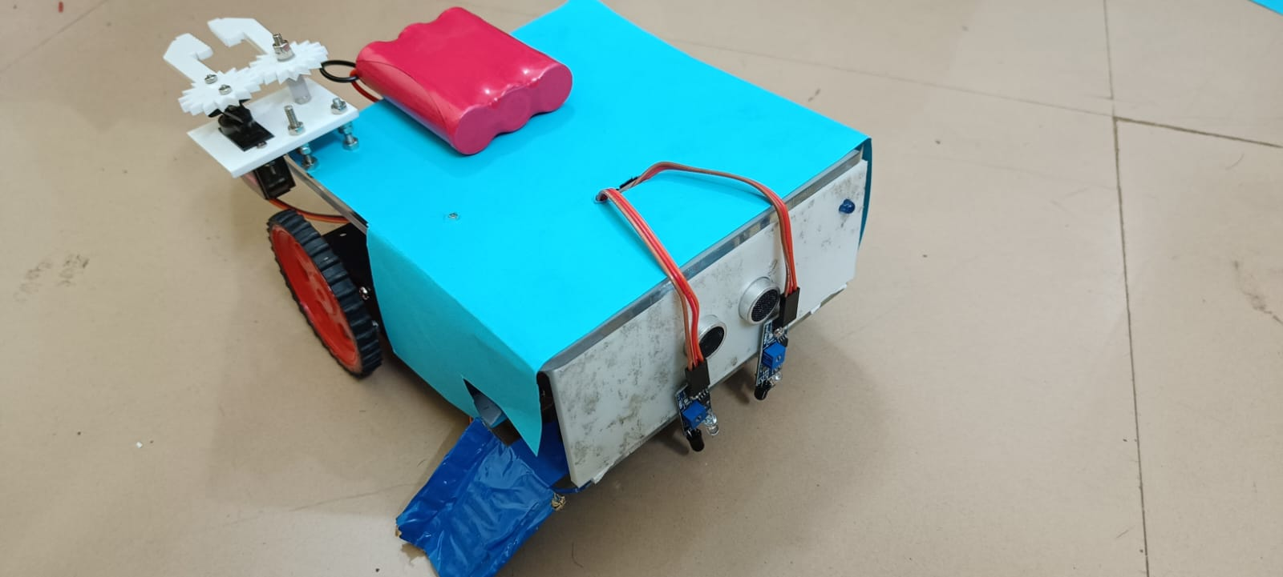

Upper Chassis:

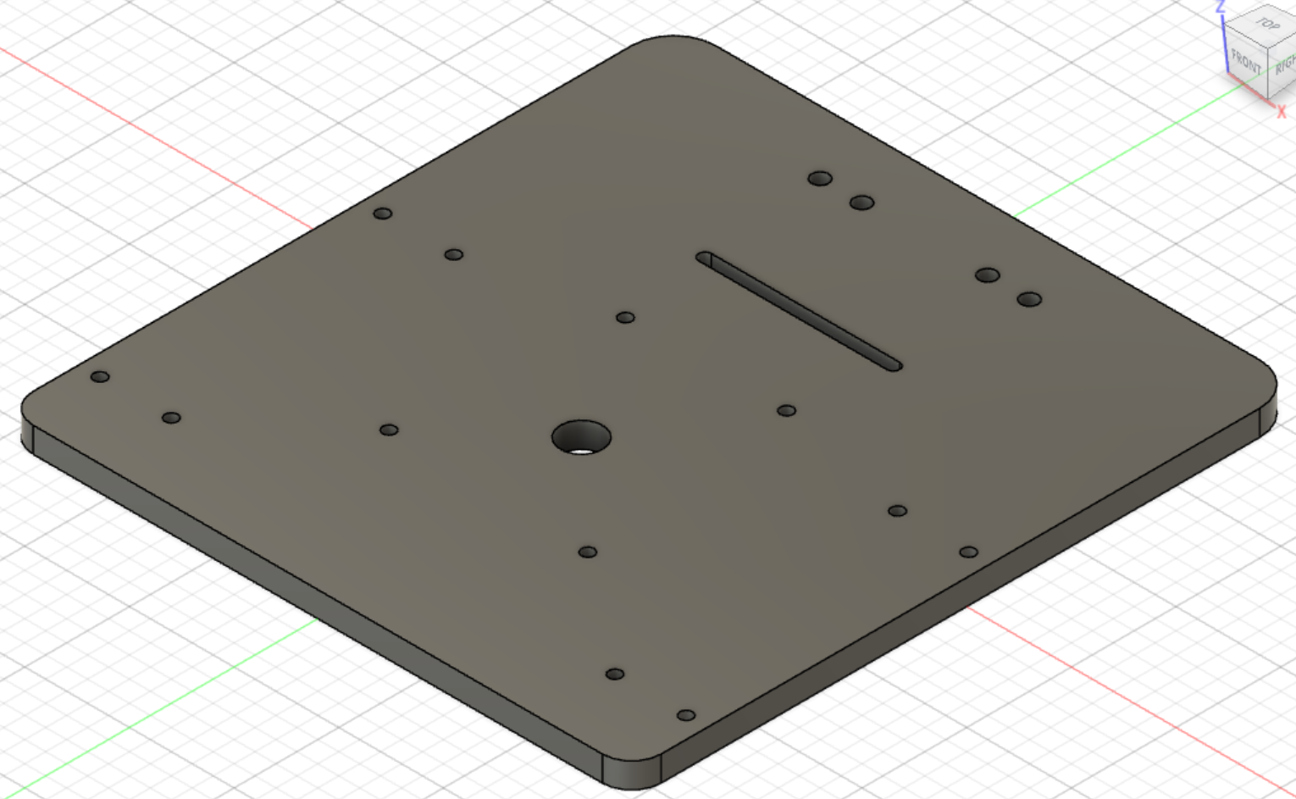

**Front Part:**

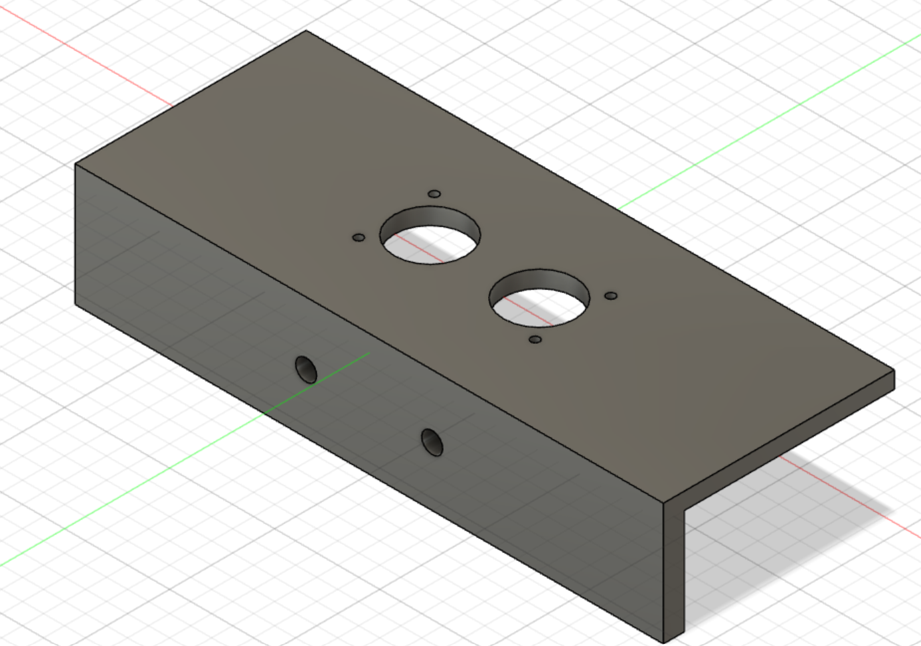

**Lower Chassis:**

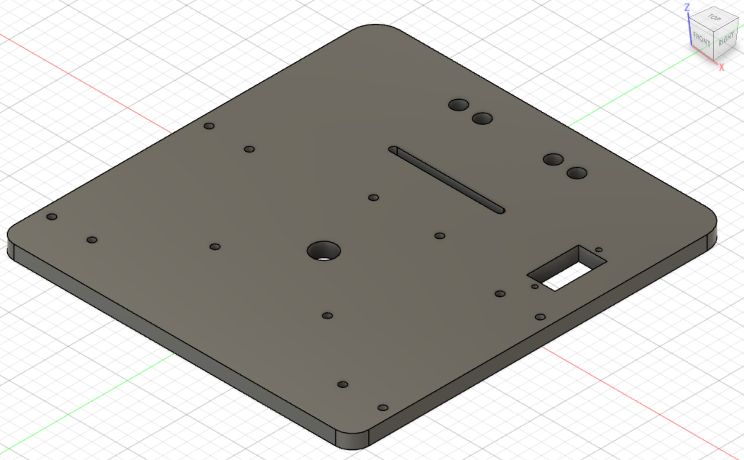

**Robotic Arm:**

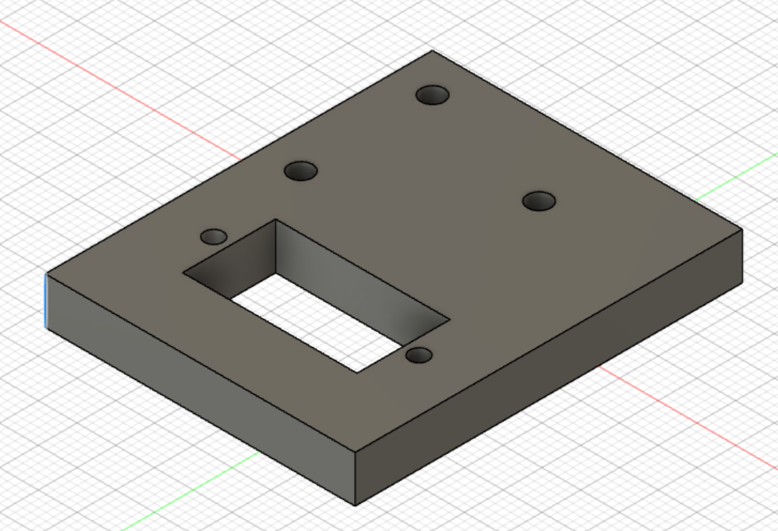

**Gears:**

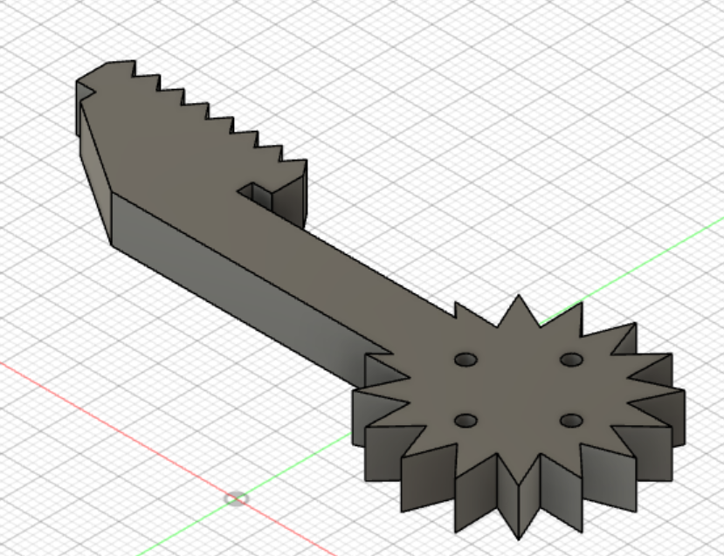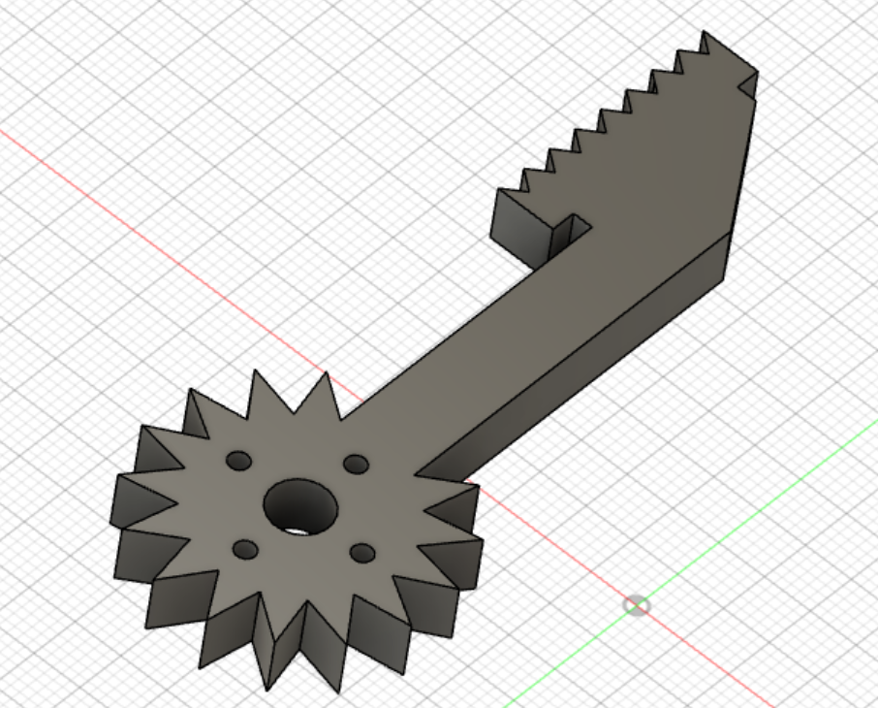

**EE design:** Picture of actual circuit assembly, it’s testing in the form of pictures, videos. Associated computer code etc.

Testing Videos:



Arduino Code:



**#include<Servo.h>**

**Servo s1;**

**int rv=400, lv=400, ldrv=50;**

**int rs,ls,ldr;**

**int ena,enb;**

**float dist,dur;**

**void setup() {**

**pinMode(1,OUTPUT);**

**pinMode(2,OUTPUT);**

**pinMode(3,OUTPUT);**

**pinMode(4,OUTPUT);**

**pinMode(5,OUTPUT);**

**pinMode(6,OUTPUT);**

**pinMode(7,OUTPUT);**

**pinMode(8,OUTPUT);**

**pinMode(9,OUTPUT);**

**digitalWrite(7,0);**

**analogWrite(5,100);**

**analogWrite(6,100);**

**s1.attach(3);**

**pinMode(10,OUTPUT);**

**pinMode(11,OUTPUT);**

**pinMode(12,INPUT);**

**pinMode(13,OUTPUT);**

**Serial.begin(9600);**

**}**

**void loop() {**

**ldr=analogRead(A2);**

**rs=analogRead(A1);**

**ls=analogRead(A0);**

**digitalWrite(13,1);**

**delayMicroseconds(5);**

**digitalWrite(13,0);**

**dur=pulseIn(12,1);**

**dist=0.017*dur;**

**Serial.println(ldr);**

**if(ldr>ldrv)**

**{**

**if(dist>6)**

**{**

**digitalWrite(7,0);**

**if(rs<rv && ls<lv)**

**{**

**fwd();**

**}**

**if(rs<rv && ls>lv)**

**{**

**right();**

**}**

**if(rs>rv && ls<lv)**

**{**

**left();**

**}**

**if(rs>rv && ls>lv)**

**{**

**hal();**

**digitalWrite(7,1);**

**}**

**}**

**else**

**{**

**hal();**

**digitalWrite(7,1);**

**}**

**}**

**else**

**{**

**digitalWrite(7,1);**

**hal();**

**delay(500);**

**for(int i=90;i>=0;i--)**

**{**

**s1.write(i);**

**delay(10);**

**}**

**s1.write(90);**

**fwd();**

**delay(300);**

**Final}**

**}**

**void fwd()**

**{**

**digitalWrite(8,1);**

**digitalWrite(9,0);**

**digitalWrite(10,1);**

**digitalWrite(11,0);**

**}**

**void back()**

**{**

**digitalWrite(8,0);**

**digitalWrite(9,1);**

**digitalWrite(10,0);**

**digitalWrite(11,1);**

**}**

**void left()**

**{**

**digitalWrite(8,1);**

**digitalWrite(9,0);**

**digitalWrite(10,0);**

**digitalWrite(11,1);**

**}**

**void right()**

**{**

**digitalWrite(8,0);**

**digitalWrite(9,1);**

**digitalWrite(10,1);**

**digitalWrite(11,0);**

**}**

**void hal()**

**{**

**digitalWrite(8,0);**

**digitalWrite(9,0);**

**digitalWrite(10,0);**

**digitalWrite(11,0);**

**}**

YouTube Video Link:

<https://youtu.be/RuAPijH-BLk>